**CODE :**

<?php

echo "My first PHP script! <br>";

echo "Hello World<br>";

$a=5;

$b=4;

echo "Sum : ",$a+$b;

?>

**OUTPUT :**

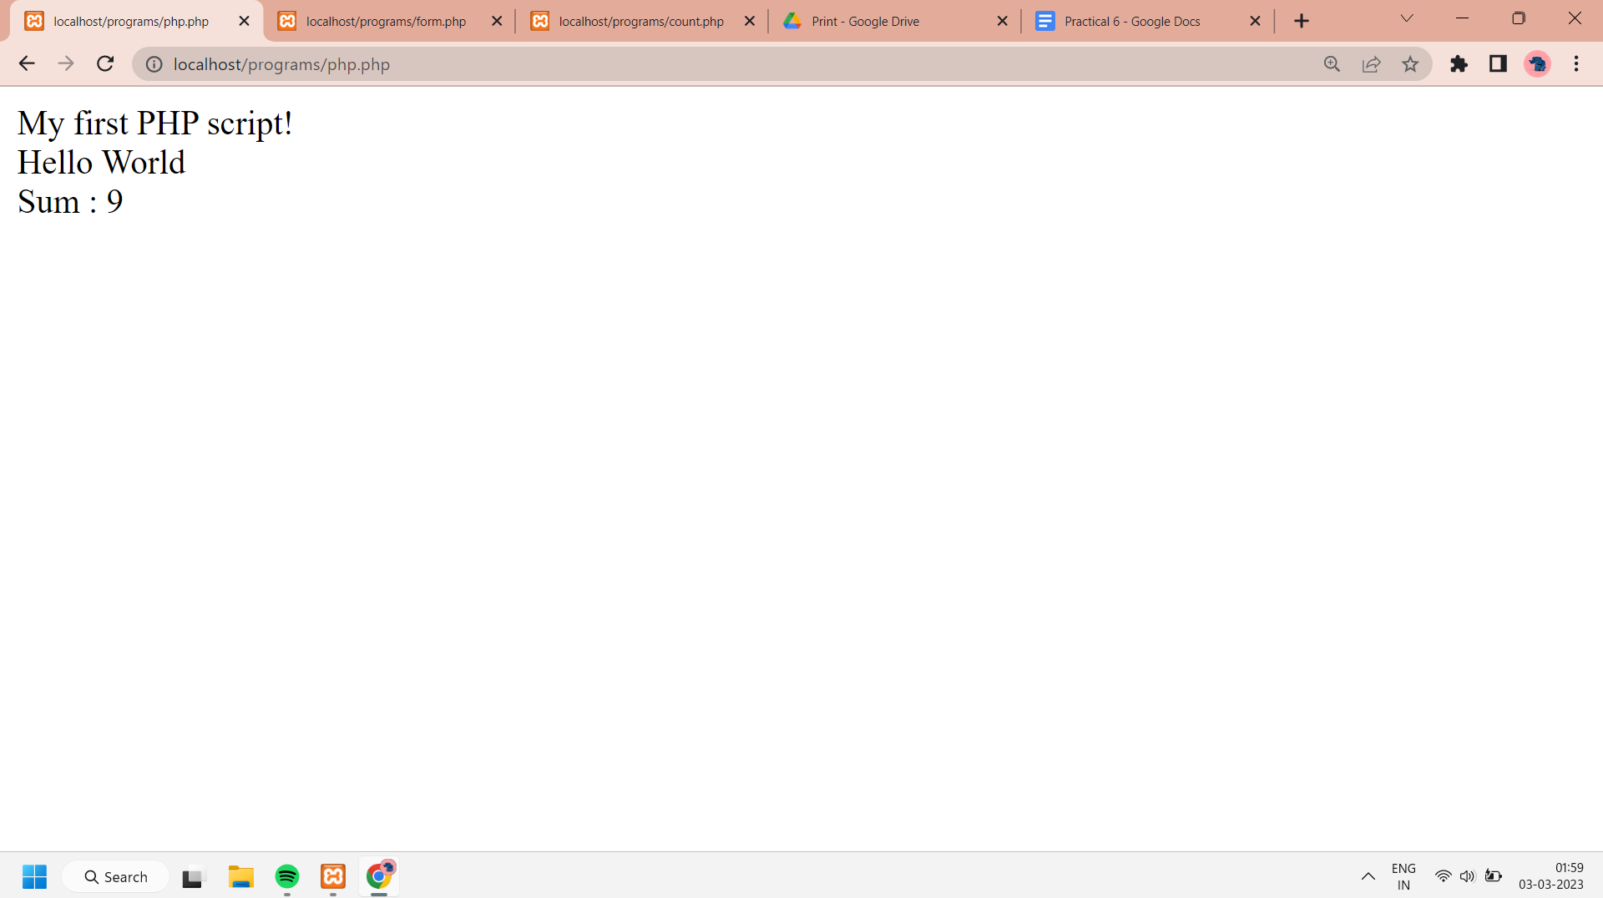

1. **Write a PHP program to keep track of the number of visitors visiting the web page and to display this count of visitors, with proper headings.**

**CODE :**

<?php

print"<h3> REFRESH PAGE </h3>";

$name = "counter.txt";

$file = fopen($name,"r");

$hits = fscanf($file,"%d");

fclose($file);

$hits[0]++;

$file = fopen($name,"w");

fprintf($file,"%d",$hits[0]);

fclose($file);

print "Total number of views : " .$hits[0];

?>

**OUTPUT :**

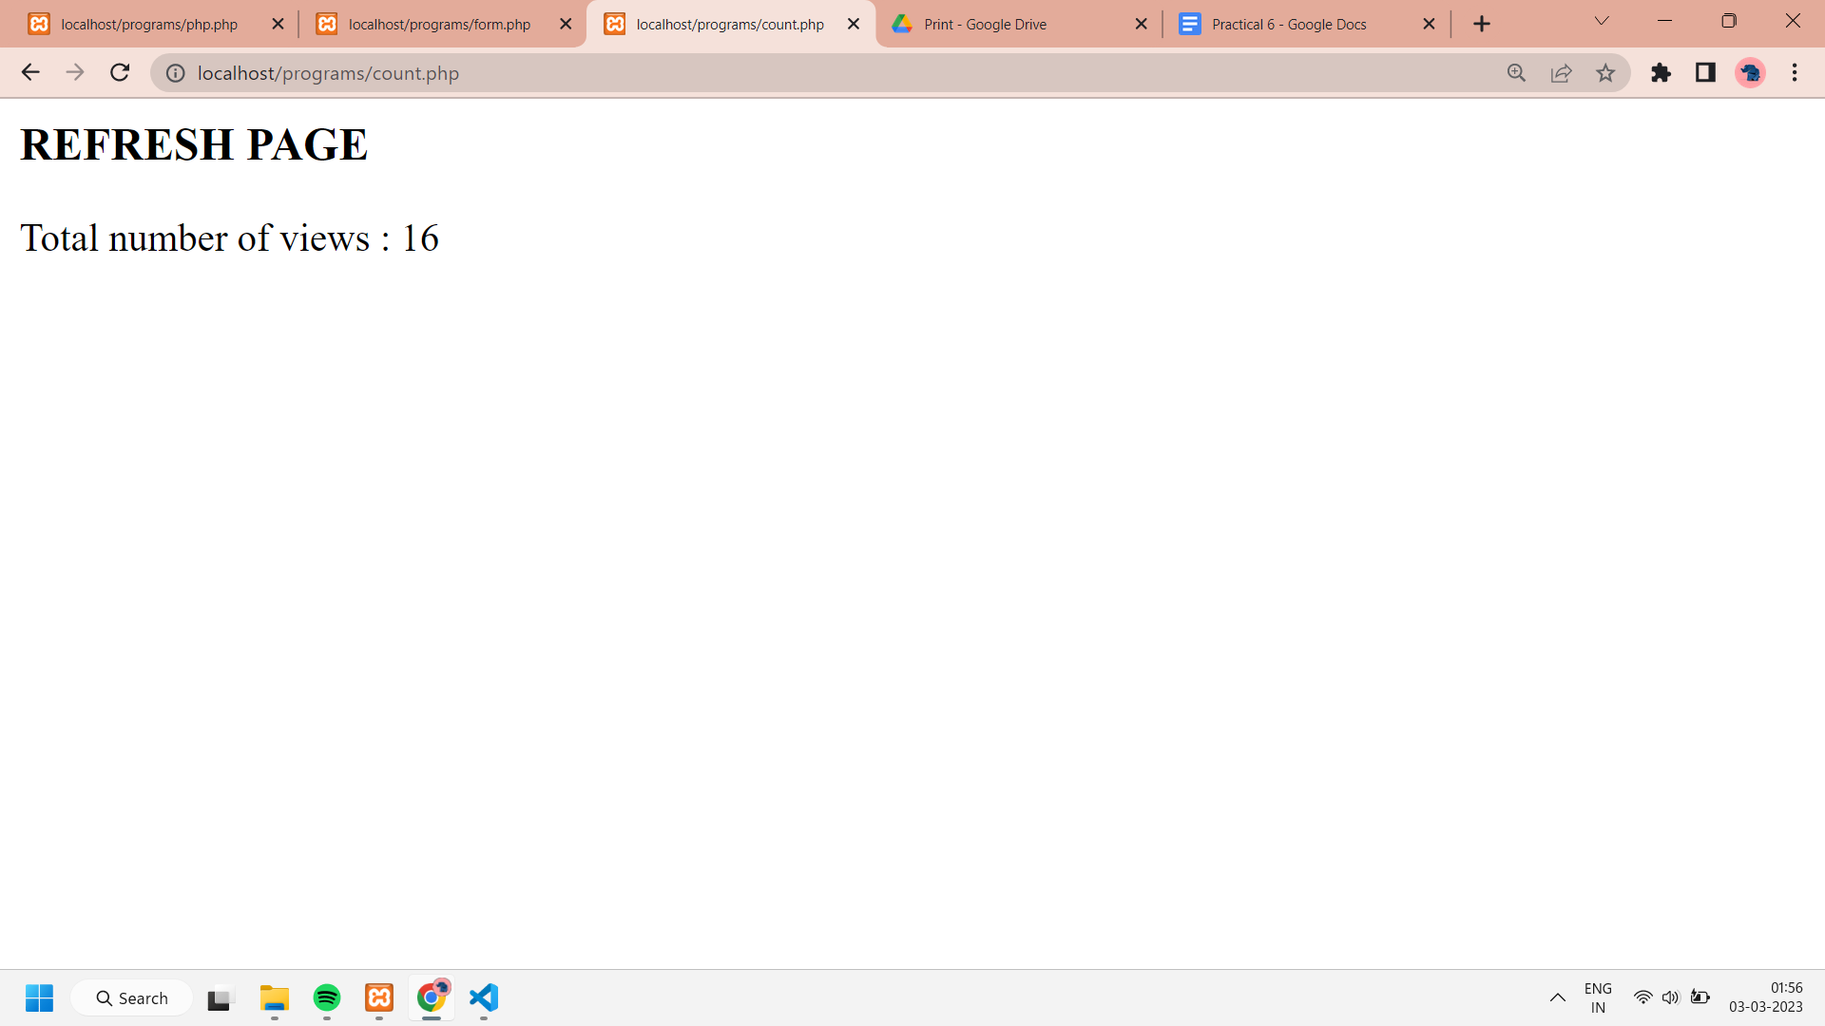

1. **Write a PHP program to display a digital clock which displays The current time of the server.**

**CODE :**

<html>

<body>

<style>

p

{

color:skyblue;

font-size:90px;

position:absolute;

top: 40%;

left: 50%;

transform: translate(-50%, -50%);

}

h1

{

color:skyblue;

font-size:50px;

text-align:center;

}

body

{

background-color:lightcoral;

}

</style>

<h1>Digital Clock showing the current time of the Server</h1>

<p> <?php echo date(" h: i : s A");?> </p>

</body>

</html>

**OUTPUT :**

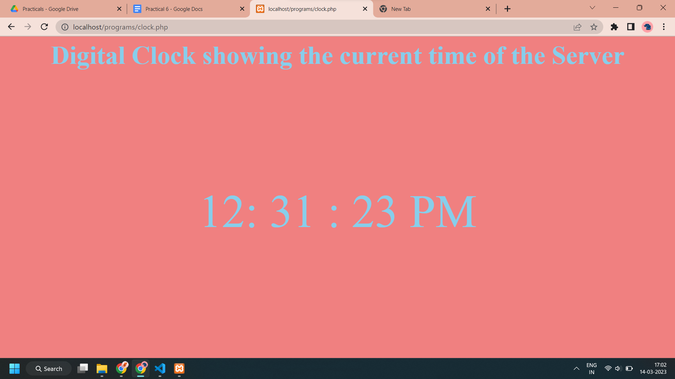

**3. Write a PHP program to take input two numbers from the user and add them.**

**CODE :**

<html>

<body>

<form method="post">

Enter First Number:

<input type="number" name="number1" /><br><br>

Enter Second Number:

<input type="number" name="number2" /><br><br>

<input type="submit" name="submit" value="Add">

</form>

<?php

if(isset($_POST['submit']))

{

$number1 = $_POST['number1'];

$number2 = $_POST['number2'];

$sum = $number1+$number2;

echo "The sum of $number1 and $number2 is: ".$sum;

}

?>

</body>

</html>

**OUTPUT :**

